Stability Analysis at plant Input and Output
Chris Bonney (March 2021)
Program Start 1
Plant Data 2
Build RSLQR model, varying Q, without actuator 3
Step Analysis to Find Best LQR Gains 3
Iterate through each controller and perform step function 4
1.1 7
1.2 7
1.3 8
2.1 9
2.2 10
2.3 11
3a 12
3b 13
3c 15
3d 16
3e 17
3f (RSLQR) 18
3g 20
3h 21
3i 22

Program Start
clear all
close all
clc
format short e
load('Hmk3_RSLQR.mat')
load('Hmk4_Hinf.mat')
Hmk4_HINF = HINF;
Hmk3_RSLQR = RSLQR;
rtd = 180/pi;
dt = 0.002;
t = 0:dt:2;
SCP.t = t;
w = logspace(-3,3,500);
SCP.w = w;
dd=0.:.001:2*pi;
xx1=cos(dd)-1;yy1=sin(dd);
metric = zeros(1,12);

Plant Data
Controller Constants
Za_V = -1.3046;
Ma = 47.711; % Positve Ma = unstable aircraft
Zd_V = -.2142;
Md = -104.83;
V = 886.78; % (fps)
Za = V*Za_V;
Zd = V*Zd_V;
w_act = 2.*pi*11; % actuator natural frequency rps
z_act = 0.707; % actuator damping
grav = 32.174; % (fps2)
%**************************************************************************
% Plant model for analysis with actuator
%**************************************************************************
% States are AOA (rad), pitch rate (rps), dele (rad), deledot (rps)
disp('Plant Model')
disp('xpdot = Ap*xp + Bp*u')
disp(' y = Cp*xp + Dp*u')
disp(' xp = AOA (rad), pitch rate q (rps), dele (rad), deledot (rps)')
disp(' u = delec (rad)')
disp(' y = Az (fps2), AOA (rad), pitch rate q (rps), dele (rad), deledot (rps)')
disp(' ')
Plant.Ap = [Za/V Za 0 Zd ;
Ma/Za 0 (Md-Ma*Zd/Za) 0 ;
0 0 0 1 ;
0 0 -w_act^2 -2*z_act*w_act];
% Input is delcmd (rad)
Plant.Bp = [0.; 0.; 0.; w_act*w_act ];
% Outputs are Az (fps2), AOA (rad), pitch rate (rps), dele (rad), deledot (rps)
Plant.Cp = eye(4);
Plant.Dp = 0.*Plant.Cp*Plant.Bp;
% Size of the plant model
[nx,~]=size(Plant.Ap);
Plant Model
xpdot = Ap*xp + Bp*u
y = Cp*xp + Dp*u
xp = AOA (rad), pitch rate q (rps), dele (rad), deledot (rps)
u = delec (rad)
y = Az (fps2), AOA (rad), pitch rate q (rps), dele (rad), deledot (rps)

Build RSLQR model, varying Q, without actuator
cmd = 1; %output to command
Ccmd = Plant.Cp(cmd,:);
Dcmd = Plant.Dp(cmd,:);
Aw = [zeros(1,1) Ccmd ;
zeros(4,1) Plant.Ap];
Bw = [Dcmd; Plant.Bp];
% Make LQR Controllers
Q = zeros(size(Aw)); %shape of Aw
R = 1;
qq = logspace(-6,-3,50); %only penalize first element (error)
Kx_lqr = zeros([length(qq),length(Aw(:,1))]);
for i=1:length(qq)
Q(1,1) = qq(i);
Kx_lqr(i,:) = lqr(Aw,Bw,Q,R);
end
Cw = [eye(5)];
Dw = [zeros(5,1)];
% Define Dynamics with Actuator (for analysis)
Ap = Plant.Ap;
Bp = Plant.Bp;
Cp = Plant.Cp;
Dp = Plant.Dp;

Step Analysis to Find Best LQR Gains
figure('Name','LQR Step Sim');
hold on
rise_time_ii = zeros(1,length(qq));
under_percent_ii = zeros(1,length(qq));

Iterate through each controller and perform step function
for itr=1:length(qq)
Kx = Kx_lqr(itr,:);
% Build Controller in Classical Form
Ac = 0;
Bc1 = [1 0 0 0];
Bc2 = [-1];
Cc = -Kx(1);
Dc1 = [-Kx(2:5)];
Dc2 = 0;
% Build Closed Loop System Model
Z = inv(eye(size(Dc1*Dp))-Dc1*Dp);
Acl = [ (Ap+Bp*Z*Dc1*Cp) (Bp*Z*Cc);
(Bc1*(Cp+Dp*Z*Dc1*Cp)) (Ac+Bc1*Dp*Z*Cc)];
Bcl = [ Bp*Z*Dc2;
(Bc2+Bc1*Dp*Z*Dc2)];
Ccl = [(Cp+Dp*Z*Dc1*Cp) (Dp*Z*Cc)];
Dcl =(Dp*Z*Dc2);
Ccl_Az = Ccl(1,:);
Dcl_Az =Dcl(1,:);
sys_cl = ss(Acl,Bcl,Ccl,Dcl);
% Check Closed Loop Stability
if max(real(eig(Acl))) > 0 %unstable
disp('Closed-Loop System is Unstable');
disp([' Most unstable eig = ', num2str(max(real(eig(Acl))))]);
return
% else %system is stable
% disp('Closed-Loop System is stable');
% damp(Acl)
end
% Step Response Time Domain Analysis
% Confirms System is connected properly and is stable
[az,~] = step(Acl,Bcl,Ccl_Az,Dcl_Az,1,t); % step simulation
az_error=abs(ones(size(az))-az); % error in step function
fv=az_error(numel(az_error)); % final value of error
e_n = az_error-fv*ones(size(az_error))-0.36*ones(size(az_error)); % adjusted error
e_n1= abs(e_n) + e_n;
rise_time_ii(itr) = crosst(e_n1,t); % store rise time
under_percent_ii(itr) = -min(az)*100; % store percent undershoot
% sys_HS = ss(Acl,Bcl,Ccl_Az,Dcl_Az);
% figure('Name','LQR Step Sim'),
% plot(t,y_HS,'LineWidth',2);grid
plot(t,az);
% legend('Az','Location','Best');
end
% Pick most similar to HW 3
hw3_rise = Hmk3_RSLQR.metric(5);
[~,best_ii] = min(abs(rise_time_ii-hw3_rise));
best_qq = qq(best_ii);
Q(1,1) = best_qq;
% Rebuild best controller
Kx = Kx_lqr(best_ii,:); % best Kx
Ac = 0;
Bc1 = [1 0 0 0];
Bc2 = [-1];
Cc = -Kx(1);
Dc1 = [-Kx(2:5)];
Dc2 = 0;
% Build Closed Loop System Model
Z = inv(eye(size(Dc1*Dp))-Dc1*Dp);
Acl = [ (Ap+Bp*Z*Dc1*Cp) (Bp*Z*Cc);
(Bc1*(Cp+Dp*Z*Dc1*Cp)) (Ac+Bc1*Dp*Z*Cc)];
Bcl = [ Bp*Z*Dc2;
(Bc2+Bc1*Dp*Z*Dc2)];
Ccl = [(Cp+Dp*Z*Dc1*Cp) (Dp*Z*Cc)];
Dcl =(Dp*Z*Dc2);
Ccl_Az = Ccl(1,:);
Dcl_Az =Dcl(1,:);
sys_cl = ss(Acl,Bcl,Ccl,Dcl);
[y,~] = step(Acl,Bcl,Ccl,Dcl,1,t); % step simulation of best system
plot(t,y(:,1),'r','LineWidth',1.5);
az = y(:,1); % acceleration (fps2)
aze = abs(ones(size(az))-az); % error for az
taur = 0.; taus= 0.; % rise time and settling time
fv = aze(numel(aze)); % final value of the error
e_n = aze - fv*ones(size(aze)) - 0.36*ones(size(aze));
e_n1 = abs(e_n) + e_n;
taur = crosst(e_n1,t); % rise time
risetime = taur;
metric(5) = taur;
e_n = aze - fv*ones(size(aze)) - 0.05*ones(size(aze));
e_n1 = abs(e_n) + e_n;
taus = crosst(e_n1,t); % settling time
settletime = taus;
metric(6) = taus;
plot(Hmk3_RSLQR.t, Hmk3_RSLQR.y(:,1),'b','LineWidth',2);
title('Matching LQR Rise Times')
xlabel('Time (sec)')
ylabel('A_z fps^2')
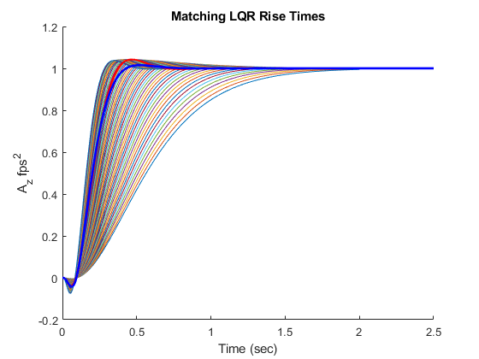

1.1
Aw
Bw
Q
R
Kx
Aw =
0 1.0000e+00 0 0 0
0 -1.3046e+00 -1.1569e+03 0 -1.8995e+02
0 -4.1241e-02 0 -1.1266e+02 0
0 0 0 0 1.0000e+00
0 0 0 -4.7769e+03 -9.7729e+01
Bw =
0
0
0
0
4.7769e+03
Q =
1.8421e-04 0 0 0 0
0 0 0 0 0
0 0 0 0 0
0 0 0 0 0
0 0 0 0 0
R =
1
Kx =
1.3572e-02 3.2444e-03 -3.4047e-01 1.2269e+00 5.5072e-03

1.2
Ac
Bc1
Bc2
Cc
Dc1
Dc2
Ac =
0
Bc1 =
1 0 0 0
Bc2 =
-1
Cc =
-1.3572e-02
Dc1 =
-3.2444e-03 3.4047e-01 -1.2269e+00 -5.5072e-03
Dc2 =
0

1.3
F = Aw-Bw*Kx;
Lmda_cl = eig(F)
[X_cl,~] = eig(F)
Lmda_cl =
-4.8843e+01 + 4.8891e+01i
-4.8843e+01 - 4.8891e+01i
-7.5526e+00 + 9.1623e+00i
-7.5526e+00 - 9.1623e+00i
-1.2549e+01 + 0.0000e+00i
X_cl =
Columns 1 through 2
9.6351e-03 + 9.6446e-03i 9.6351e-03 - 9.6446e-03i
-9.4214e-01 + 0.0000e+00i -9.4214e-01 + 0.0000e+00i
4.4818e-03 + 5.8132e-03i 4.4818e-03 - 5.8132e-03i
4.8105e-03 + 5.7527e-04i 4.8105e-03 - 5.7527e-04i
-2.6309e-01 + 2.0710e-01i -2.6309e-01 - 2.0710e-01i
Columns 3 through 4
-5.3373e-02 - 6.4749e-02i -5.3373e-02 + 6.4749e-02i
9.9635e-01 + 0.0000e+00i 9.9635e-01 + 0.0000e+00i
3.2491e-03 - 7.6958e-03i 3.2491e-03 + 7.6958e-03i
-7.7276e-04 - 7.8013e-04i -7.7276e-04 + 7.8013e-04i
1.2984e-02 - 1.1883e-03i 1.2984e-02 + 1.1883e-03i
Column 5
7.9422e-02 + 0.0000e+00i
-9.9671e-01 + 0.0000e+00i
-1.1598e-02 + 0.0000e+00i
-9.2704e-04 + 0.0000e+00i
1.1634e-02 + 0.0000e+00i

2.1
to_keep = [3,4,5]
Lmda_r = Lmda_cl(to_keep)
X_r = X_cl(:,to_keep)
C = [eye(3) zeros(3,2)]
Ky = Kx*X_r*inv(C*X_r);
Ky = real(Ky)
to_keep =
3 4 5
Lmda_r =
-7.5526e+00 + 9.1623e+00i
-7.5526e+00 - 9.1623e+00i
-1.2549e+01 + 0.0000e+00i
X_r =
Columns 1 through 2
-5.3373e-02 - 6.4749e-02i -5.3373e-02 + 6.4749e-02i
9.9635e-01 + 0.0000e+00i 9.9635e-01 + 0.0000e+00i
3.2491e-03 - 7.6958e-03i 3.2491e-03 + 7.6958e-03i
-7.7276e-04 - 7.8013e-04i -7.7276e-04 + 7.8013e-04i
1.2984e-02 - 1.1883e-03i 1.2984e-02 + 1.1883e-03i
Column 3
7.9422e-02 + 0.0000e+00i
-9.9671e-01 + 0.0000e+00i
-1.1598e-02 + 0.0000e+00i
-9.2704e-04 + 0.0000e+00i
1.1634e-02 + 0.0000e+00i
C =
1 0 0 0 0
0 1 0 0 0
0 0 1 0 0
Ky =
4.1720e-03 1.1948e-03 -1.3615e-01

2.2
SCP.Ac = 0;
SCP.Bc1 = [1 0 0 0];
SCP.Bc2 = [-1];
SCP.Cc = -Ky(1);
SCP.Dc1 = [-Ky(2:3) 0 0];
SCP.Dc2 = 0;
Ac = SCP.Ac
Bc1 = SCP.Bc1
Bc2 = SCP.Bc2
Cc = SCP.Cc
Dc1 = SCP.Dc1
Dc2 = SCP.Dc2
Ac =
0
Bc1 =
1 0 0 0
Bc2 =
-1
Cc =
-4.1720e-03
Dc1 =
-1.1948e-03 1.3615e-01 0 0
Dc2 =
0

2.3
Z = inv(eye(size(Dc1*Dp))-Dc1*Dp);
SCP.Acl = [ (Ap+Bp*Z*Dc1*Cp) (Bp*Z*Cc);
(Bc1*(Cp+Dp*Z*Dc1*Cp)) (Ac+Bc1*Dp*Z*Cc)];
SCP.Bcl = [ Bp*Z*Dc2;
(Bc2+Bc1*Dp*Z*Dc2)];
SCP.Ccl = [(Cp+Dp*Z*Dc1*Cp) (Dp*Z*Cc)];
SCP.Dcl =(Dp*Z*Dc2);
SCP.Ccl_Az = Ccl(1,:);
SCP.Dcl_Az =Dcl(1,:);
SCP.sys_cl = ss(Acl,Bcl,Ccl,Dcl);
sys_cl = SCP.sys_cl;
Lmda_scp = eig(SCP.Acl)
[X_scp,~] = eig(SCP.Acl)
Lmda_scp =
-3.5689e+01 + 1.3941e+01i
-3.5689e+01 - 1.3941e+01i
-1.2549e+01 + 0.0000e+00i
-7.5526e+00 + 9.1623e+00i
-7.5526e+00 - 9.1623e+00i
X_scp =
Columns 1 through 2
-9.6696e-01 + 0.0000e+00i -9.6696e-01 + 0.0000e+00i
1.2751e-02 + 1.3349e-02i 1.2751e-02 - 1.3349e-02i
6.0451e-03 + 2.6509e-03i 6.0451e-03 - 2.6509e-03i
-2.5270e-01 - 1.0335e-02i -2.5270e-01 + 1.0335e-02i
2.3507e-02 + 9.1825e-03i 2.3507e-02 - 9.1825e-03i
Columns 3 through 4
-9.9671e-01 + 0.0000e+00i 9.9635e-01 + 0.0000e+00i
-1.1598e-02 + 0.0000e+00i 3.2491e-03 - 7.6958e-03i
-9.2704e-04 + 0.0000e+00i -7.7276e-04 - 7.8013e-04i
1.1634e-02 + 0.0000e+00i 1.2984e-02 - 1.1883e-03i
7.9422e-02 + 0.0000e+00i -5.3373e-02 - 6.4749e-02i
Column 5
9.9635e-01 + 0.0000e+00i
3.2491e-03 + 7.6958e-03i
-7.7276e-04 + 7.8013e-04i
1.2984e-02 + 1.1883e-03i
-5.3373e-02 + 6.4749e-02i

3a
[~,y_scp] = step(SCP.Acl,SCP.Bcl,SCP.Ccl,SCP.Dcl,1, t);
az = y_scp(:,1); % acceleration (fps2)
SCP.y = y_scp;
aze = abs(ones(size(az))-az); % error for az
taur = 0.; taus= 0.; % rise time and settling time
fv = aze(numel(aze)); % final value of the error
e_n = aze - fv*ones(size(aze)) - 0.36*ones(size(aze));
e_n1 = abs(e_n) + e_n;
taur = crosst(e_n1,t); % rise time
SCP.risetime = taur;
SCP.metric(5) = taur;
e_n = aze - fv*ones(size(aze)) - 0.05*ones(size(aze));
e_n1 = abs(e_n) + e_n;
taus = crosst(e_n1,t); % settling time
SCP.settletime = taus;
SCP.metric(6) = taus;
figure
grid on
hold on
plot(t,y(:,1),'b','LineWidth',2');
plot(t,SCP.y(:,1),'r','LineWidth',2);
plot(RSLQR.t,RSLQR.y(:,1),'k','LineWidth',2);
plot(HINF.t,HINF.y(:,1),'g','LineWidth',2);
legend({['Actuator Feedback: Tr=',num2str(risetime)],...
['SCP response: Tr=',num2str(SCP.risetime)],...
['RSLQR response: Tr=',num2str(RSLQR.risetime)],...
['Hinf response: Tr=',num2str(HINF.metric(5))]},...
'Location','best');
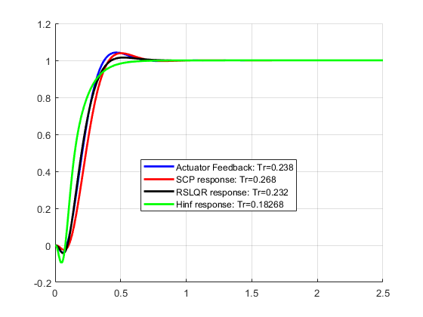

3b
Ain = [ Ap 0.*Bp*Cc; Bc1*Cp Ac];
Bin = [ Bp; Bc1*Dp];
Cin = -[ Dc1*Cp Cc];%change sign for loop gain
Din = -[ Dc1*Dp];
sys_u = ss(Ain,Bin,Cin,Din);
Aout = [ Ap Bp*Cc; 0.*Bc1*Cp Ac];
Bout = [ Bp*Dc1; Bc1];
Cout = -[ Cp Dp*Cc];%change sign for loop gain
Dout = -[ Dp*Dc1];
sys_y = ss(Aout,Bout,Cout,Dout);
Bv = [ Bp*Z*Dc1;
(Bc1+Bc1*Dp*Z*Dc1)];
Cv = [ Z*Dc1*Cp Z*Cc];
Cvv = [ Cv ; Cv*Acl ];
Dv = Z*Dc1;
Dvv = [ Dv; Cv*Bv];
sys_noise = ss(Acl,Bv,Cvv,Dvv);
Lu = squeeze(freqresp(sys_u,w));
Ly = squeeze(freqresp(sys_y,w));
Lv = squeeze(freqresp(sys_noise,w));
SCP.Lu = Lu;
SCP.Ly = Ly;
SCP.Lv = Lv;
T = squeeze(freqresp(sys_cl,w));
S = 1 - T;
SCP.T = T;
SCP.S = S;
SCP.dele_Az = 20*log10(abs(squeeze(Lv(1,1,:))));
SCP.dele_q = 20*log10(abs(squeeze(Lv(1,3,:))));
SCP.deledot_Az = 20*log10(abs(squeeze(Lv(2,1,:))));
SCP.deledot_q = 20*log10(abs(squeeze(Lv(2,3,:))));
classical_input_margins = allmargin(sys_u);
SCP.LGCF = classical_input_margins.PMFrequency(1);
SCP.metric(4) = SCP.LGCF;
rd_u = sigma(sys_u,w,2);
SCP.rd = rd_u;
RDu_min = min(min(abs(rd_u)));
SCP.rd_min = RDu_min;
SCP.metric(2) = SCP.rd_min;
sr_u = sigma(sys_u,w,3);
SCP.sr = sr_u;
SRu_min = min(min(abs(sr_u)));
SCP.sr_min = SRu_min;
SCP.metric(3) = SCP.sr_min;
Tmax = max(T,[],2);
SCP.Tmax = 20*log10(abs(Tmax));
SCP.metrix(11) = SCP.Tmax(1);
Smax = max(S,[],2);
SCP.Smax = 20*log10(abs(Smax));
SCP.metric(12) = SCP.Smax(1);
[nCp,nAp] = size(Cp);
[~,nBp] = size(Bp);
for i=1:numel(w)
s = sqrt(-1)*w(i);
Lout = Cout*inv(s*eye(size(Aout))-Aout)*Bout+Dout;
% This loops computes SISO freq response at plant output one loop open,
% rest closed
for jj = 1:nCp
Fyjj = eye(nCp);
Fyjj(jj,jj) = 0.;
Tyjj = inv(eye(nCp) + Lout*Fyjj)*Lout;
Tyj(jj,i) = Tyjj(jj,jj);
end
end
for jj=1:nCp
v_min(jj) = min(min(abs(1.+Tyj(jj,:))));
end
figure('Name','Nyquist Plot'),
plot(xx1,yy1,'k:',...
real(squeeze(RSLQR.Lu)),imag(squeeze(RSLQR.Lu)),'r',...
real(squeeze(HINF.Lu)),imag(squeeze(HINF.Lu)),'g',...
real(squeeze(SCP.Lu)),imag(squeeze(SCP.Lu)),'b',...
'LineWidth',2);grid
axis([-3 3 -3 3]);
xlabel('Re(Lu)')
ylabel('Im(Lu)')
legend('Unit Circle','RSLQR Lu','HINF Lu','SCP Lu');
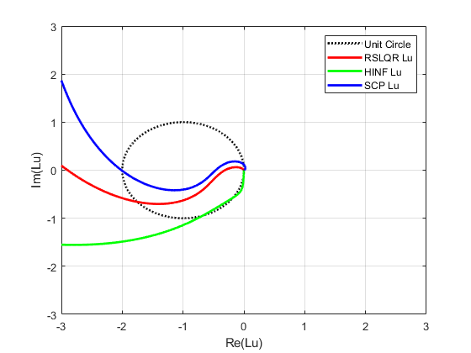

3c
figure('Name','Bode Magnitude at Plant Input'),
semilogx(RSLQR.w,20*log10(abs(squeeze(RSLQR.Lu))),'r',...
HINF.w,20*log10(abs(squeeze(HINF.Lu))),'g',...
SCP.w,20*log10(abs(squeeze(SCP.Lu))),'b',...
'LineWidth',2);grid
legend([ 'Hmk3 RSLQR LGCF = ' num2str(RSLQR.metric(4)) ],...
[ 'Hinf-SF LGCF = ' num2str(HINF.metric(4)) ],...
[ 'Hmk5 SCP LGCF = ' num2str(SCP.metric(4)) ],...
'Location','Best');
xlabel('Frequency (rps)')
ylabel('Mag')
title('Bode at Input')
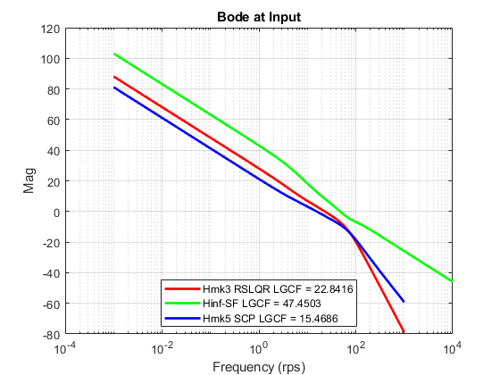

3d
figure('Name','Return Difference at Plant Input'),
semilogx(RSLQR.w,20*log10(abs(RSLQR.rd)),'r',...
HINF.w,20*log10(abs(HINF.rd)),'g',...
SCP.w,20*log10(abs(SCP.rd)),'b',...
'LineWidth',2);grid
legend([' RSLQR min(I+Lu) = ' num2str(RSLQR.metric(2))],...
[' Hinf min(I+Lu) = ' num2str(HINF.metric(2))],...
[' SCP I+Lu min = ' num2str(SCP.metric(2))],...
'Location','Best');
xlabel('Frequency (rps)')
ylabel('Mag dB')
title('Return Difference at Plant Input')
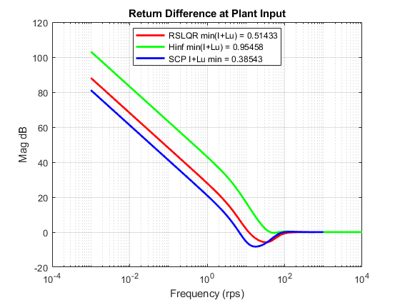

3e
figure('Name','Stability Robustness at Plant Input'),
semilogx(RSLQR.w,20*log10(abs(RSLQR.sr)),'r',...
HINF.w,20*log10(abs(HINF.sr)),'g',...
SCP.w,20*log10(abs(SCP.sr)),'b',...
'LineWidth',2);grid
legend([' RSLQR min(I+Lu) = ' num2str(RSLQR.metric(3))],...
[' Hinf min(I+Lu) = ' num2str(HINF.metric(3))],...
[' SCP I+Lu min = ' num2str(SCP.metric(3))],...
'Location','Best');
xlabel('Frequency (rps)')
ylabel('Mag dB')
title('Stability Robustness at Plant Input')
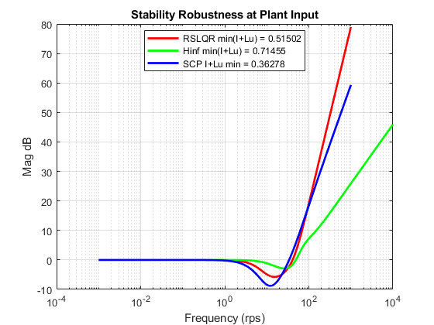

3f (RSLQR)
disp('RSLQR SV Margins');
disp(['min(I+Lu) = ' num2str(RDu_min) ' min(I+invLu) = ' num2str(SRu_min) ] )
% Return Difference Margins
RDu_nGM = 1/(1+RSLQR.metric(2));
RDu_pGM = 1/(1-RSLQR.metric(2));
RDu_Pha = 2*asin(RSLQR.metric(2)/2);
RDu_nGM_dB = 20*log10(RDu_nGM);
RDu_pGM_dB = 20*log10(RDu_pGM);
RDu_Pha_deg = 180*RDu_Pha/pi ;
disp('RDu_nGM RDu_pGM RDu_Pha')
disp([num2str(RDu_nGM) ' ' num2str(RDu_pGM) ' ' num2str(RDu_Pha)])
disp([num2str(RDu_nGM_dB) ' dB ' num2str(RDu_pGM_dB) ' dB ' num2str(RDu_Pha_deg) ' deg'])
% Stability Robustness Margins
SRu_nGM = 1-RSLQR.metric(3);
SRu_pGM = 1+RSLQR.metric(3);
SRu_Pha = 2*asin(RSLQR.metric(3)/2);
SRu_nGM_dB = 20*log10(SRu_nGM);
SRu_pGM_dB = 20*log10(SRu_pGM);
SRu_Pha_deg = 180*SRu_Pha/pi ;
disp('SRu_nGM SRu_pGM SRu_Pha')
disp([num2str(SRu_nGM) ' ' num2str(SRu_pGM) ' ' num2str(SRu_Pha)])
disp([num2str(SRu_nGM_dB) ' dB ' num2str(SRu_pGM_dB) ' dB ' num2str(SRu_Pha_deg) ' deg'])
% Combined Singular Value Margins
disp(sprintf([' SV GM- SV GM+ SV +/-PM \n', ...
num2str(min(RDu_nGM_dB,SRu_nGM_dB)) 'dB ' num2str(max(RDu_pGM_dB,SRu_pGM_dB)) 'dB ' num2str(max(RDu_Pha_deg,SRu_Pha_deg)) 'deg']));
disp(' ')
disp('HINF SV Margins');
disp(['min(I+Lu) = ' num2str(RDu_min) ' min(I+invLu) = ' num2str(SRu_min) ] )
% Return Difference Margins
RDu_nGM = 1/(1+HINF.metric(2));
RDu_pGM = 1/(1-HINF.metric(2));
RDu_Pha = 2*asin(HINF.metric(2)/2);
RDu_nGM_dB = 20*log10(RDu_nGM);
RDu_pGM_dB = 20*log10(RDu_pGM);
RDu_Pha_deg = 180*RDu_Pha/pi ;
disp('RDu_nGM RDu_pGM RDu_Pha')
disp([num2str(RDu_nGM) ' ' num2str(RDu_pGM) ' ' num2str(RDu_Pha)])
disp([num2str(RDu_nGM_dB) ' dB ' num2str(RDu_pGM_dB) ' dB ' num2str(RDu_Pha_deg) ' deg'])
% Stability Robustness Margins
SRu_nGM = 1-HINF.metric(3);
SRu_pGM = 1+HINF.metric(3);
SRu_Pha = 2*asin(HINF.metric(3)/2);
SRu_nGM_dB = 20*log10(SRu_nGM);
SRu_pGM_dB = 20*log10(SRu_pGM);
SRu_Pha_deg = 180*SRu_Pha/pi ;
disp('SRu_nGM SRu_pGM SRu_Pha')
disp([num2str(SRu_nGM) ' ' num2str(SRu_pGM) ' ' num2str(SRu_Pha)])
disp([num2str(SRu_nGM_dB) ' dB ' num2str(SRu_pGM_dB) ' dB ' num2str(SRu_Pha_deg) ' deg'])
% Combined Singular Value Margins
disp(sprintf([' SV GM- SV GM+ SV +/-PM \n', ...
num2str(min(RDu_nGM_dB,SRu_nGM_dB)) 'dB ' num2str(max(RDu_pGM_dB,SRu_pGM_dB)) 'dB ' num2str(max(RDu_Pha_deg,SRu_Pha_deg)) 'deg']));
disp(' ')
disp('SCP SV Margins');
disp(['min(I+Lu) = ' num2str(RDu_min) ' min(I+invLu) = ' num2str(SRu_min) ] )
% Return Difference Margins
RDu_nGM = 1/(1+SCP.metric(2));
RDu_pGM = 1/(1-SCP.metric(2));
RDu_Pha = 2*asin(SCP.metric(2)/2);
RDu_nGM_dB = 20*log10(RDu_nGM);
RDu_pGM_dB = 20*log10(RDu_pGM);
RDu_Pha_deg = 180*RDu_Pha/pi ;
disp('RDu_nGM RDu_pGM RDu_Pha')
disp([num2str(RDu_nGM) ' ' num2str(RDu_pGM) ' ' num2str(RDu_Pha)])
disp([num2str(RDu_nGM_dB) ' dB ' num2str(RDu_pGM_dB) ' dB ' num2str(RDu_Pha_deg) ' deg'])
% Stability Robustness Margins
SRu_nGM = 1-SCP.metric(3);
SRu_pGM = 1+SCP.metric(3);
SRu_Pha = 2*asin(SCP.metric(3)/2);
SRu_nGM_dB = 20*log10(SRu_nGM);
SRu_pGM_dB = 20*log10(SRu_pGM);
SRu_Pha_deg = 180*SRu_Pha/pi ;
disp('SRu_nGM SRu_pGM SRu_Pha')
disp([num2str(SRu_nGM) ' ' num2str(SRu_pGM) ' ' num2str(SRu_Pha)])
disp([num2str(SRu_nGM_dB) ' dB ' num2str(SRu_pGM_dB) ' dB ' num2str(SRu_Pha_deg) ' deg'])
% Combined Singular Value Margins
disp(sprintf([' SV GM- SV GM+ SV +/-PM \n', ...
num2str(min(RDu_nGM_dB,SRu_nGM_dB)) 'dB ' num2str(max(RDu_pGM_dB,SRu_pGM_dB)) 'dB ' num2str(max(RDu_Pha_deg,SRu_Pha_deg)) 'deg']));
RSLQR SV Margins
min(I+Lu) = 0.38543 min(I+invLu) = 0.36278
RDu_nGM RDu_pGM RDu_Pha
0.66036 2.059 0.52017
-3.6044 dB 6.2731 dB 29.8037 deg
SRu_nGM SRu_pGM SRu_Pha
0.48498 1.515 0.52089
-6.2855 dB 3.6084 dB 29.8447 deg
SV GM- SV GM+ SV +/-PM
-6.2855dB 6.2731dB 29.8447deg
HINF SV Margins
min(I+Lu) = 0.38543 min(I+invLu) = 0.36278
RDu_nGM RDu_pGM RDu_Pha
0.51162 22.0144 0.99513
-5.821 dB 26.8541 dB 57.0168 deg
SRu_nGM SRu_pGM SRu_Pha
0.28545 1.7146 0.7307
-10.8895 dB 4.683 dB 41.866 deg
SV GM- SV GM+ SV +/-PM
-10.8895dB 26.8541dB 57.0168deg
SCP SV Margins
min(I+Lu) = 0.38543 min(I+invLu) = 0.36278
RDu_nGM RDu_pGM RDu_Pha
0.7218 1.6272 0.38786
-2.8317 dB 4.2286 dB 22.2227 deg
SRu_nGM SRu_pGM SRu_Pha
0.63722 1.3628 0.3648
-3.9143 dB 2.6885 dB 20.9017 deg
SV GM- SV GM+ SV +/-PM
-3.9143dB 4.2286dB 22.2227deg

3g
figure('Name','Sens S');
semilogx(RSLQR.w,20*log10(abs(RSLQR.S(1,:))),'r',...
HINF.w,20*log10(abs(HINF.S(1,:))),'g',...
SCP.w,20*log10(abs(SCP.S(1,:))),'b',...
'LineWidth',2);grid
legend(['RSLQR Smax = ' num2str(RSLQR.metric(12)) ],...
['HINF Smax = ' num2str(HINF.metric(12)) ],...
['SCP Smax = ' num2str(SCP.metric(12)) ],...
'Location','Best');
title('Sens S');
xlabel('Freq (rps)');ylabel('Mag (dB)');
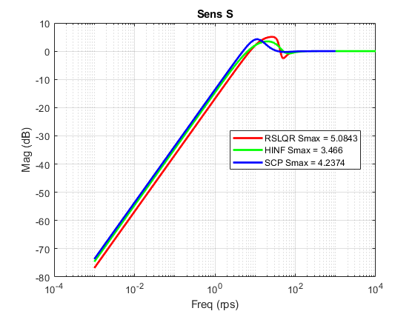

3h
figure('Name','Comp Sens T');
semilogx(RSLQR.w,20*log10(abs(RSLQR.T(1,:))),'r',...
HINF.w,20*log10(abs(HINF.T(1,:))),'g',...
SCP.w,20*log10(abs(SCP.T(1,:))),'b',...
'LineWidth',2);grid
legend(['RSLQR Tmax = ' num2str(RSLQR.metric(11)) ],...
['HINF Tmax = ' num2str(HINF.metric(11)) ],...
['SCP Tmax = ' num2str(SCP.metric(11)) ],...
'Location','Best');
title('Comp Sens T');
xlabel('Freq (rps)');ylabel('Mag (dB)');
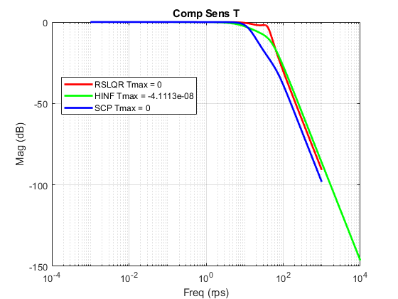

3i
figure('Name','Noise-2-Control');
semilogx(RSLQR.w,RSLQR.dele_Az,'r',RSLQR.w,RSLQR.dele_q,'r--',...
HINF.w,HINF.dele_Az,'g',HINF.w,HINF.dele_q,'g--',...
SCP.w,SCP.dele_Az,'b',SCP.w,SCP.dele_q,'b--',...
'LineWidth',2);
legend('Az RSLQR','q RSLQR',...
'Az HINF','q HINF',...
'Az SCP','q SCP',...
'Location','Best');
title(['Noise to Control ']);
xlabel('Freq (rps)');ylabel('Mag (dB)');
grid;
figure('Name','Noise-2-Control Rate');
semilogx(RSLQR.w,RSLQR.deledot_Az,'r',RSLQR.w,RSLQR.deledot_q,'r--',...
HINF.w,HINF.deledot_Az,'g',HINF.w,HINF.deledot_q,'g--',...
SCP.w,SCP.deledot_Az,'b',SCP.w,SCP.deledot_q,'b--',...
'LineWidth',2);
legend('Az Hinf','q Hinf',...
'Az RSlqr','q RSlqr',...
'Location','Best');
title(['Noise to Control Rate']);
xlabel('Freq (rps)');ylabel('Mag (dB)');
grid;
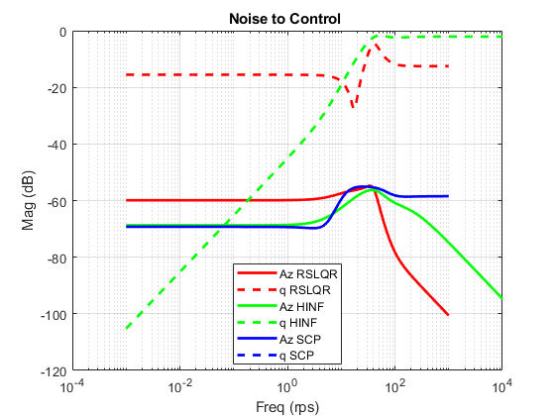
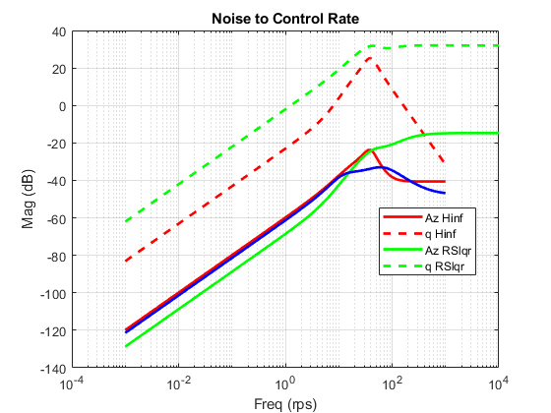
Published with MATLAB® R2020a

